On iPad and iPhone, the option for a participant to change their name comes up automatically and Participants can change their name at sign-in. If it does not, they can change their name once they see themselves in the Participant area.
Once the host joins, debtors are admitted to the waiting room. Debtors should do the following.
- Click on Participants

- The Participants Panel will open on the right of the screen. 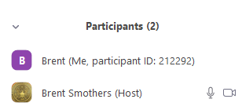

- Debtors should find their name and hover the mouse pointer over it. It will show a
More button. Click the More button and it will change to Rename.

- Click the Rename button and type first name, last name and last 5 digits of case number.

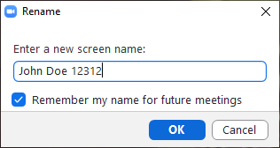

- Click OK.
- Now the debtors name has changed in the Participant Window 